**Supplementary Materials for**

**The Hopewell airburst event, 1699-1567 years ago (252-383 CE).**

Kenneth Barnett Tankersley1,2*†,

Stephen D. Meyers2*

Stephanie A. Meyers3*

James A. Jordan4*

Louis Herzner1*

David L. Lentz3*

Dylan Zedaker1*

1Department of Anthropology, University of Cincinnati, Cincinnati, OH 45221, USA.

2Department of Geology, University of Cincinnati, Cincinnati, OH 45221, USA.

3Department of Biology, University of Cincinnati, Cincinnati, OH 45221, USA.

4Reston Stable Isotope Laboratory, United States Geological Survey, Reston, VA, 20192

USA.

*These authors contributed equally to this work.

†Corresponding author. Email: tankerkh@uc.edu (K.B.T.)

1. **Ir, Pt, and Fe and Si-rich Microspherules proxy data summary.**

**table S1. Site location, Ir, Pt, and microspherule data summary.a,b.**

|  |  |  |  |  |  |  |
| --- | --- | --- | --- | --- | --- | --- |
| **Site** | **Latitude**  **North** | **Longitude**  **West** | **Ir**  **(ppb)a** | **Pt**  **(ppb)b** | **Fe and Si-rich Microspherules Maximum Size**  **(m)** | **Fe and Si-rich Microspherules Abundance (#/kg)c** |
| Turner Earthworks and Village, Hamilton Co., OH | 39.146740 | 84.314570 | 1.08 | 6.23 | 395.8 | 130 |
| Moundview Village and Mound, Hamilton Co., OH | 39.114560 | 84.364020 | 1.08 | 3.70 | 229.1 | 41 |
| Miami Fort Earthworks, Hamilton Co., OH | 39.120000 | 84.812220 | 0.38 | 1.88 | 145.6 | 37 |
| Jennison Guard Village,  Dearborn Co., IN | 39.101667 | 84.837778 | 0.38 | 1.88 | 179.8 | 74 |
| Beech Tree Village,  Clermont Co., OH | 39.128010 | 84.252000 | 0.34 | 1.60 | 50.3 | 22 |
| Milford Earthworks,  Clermont Co., OH | 39.176389 | 84.274444 | 0.32 | 1.01 | 200.0 | 23 |
| Indian Fort Earthwork,  Madison Co., KY | 37.558060 | 84.263610 | 0.30 | 0.89 | 28.2 | 9 |
| Fosters Crossing Earthwork,  Warren Co., OH | 39.323333 | 84.254444 | 0.24 | 0.77 | 50.0 | 40 |
| Krasnosky Earthwork  Hocking Co., OH | 39.523330 | 82.431940 | 0.11 | 0.53 | 40.9 | 22 |
| Marietta Earthworks and Mounds, Washington Co., OH | 39.420000 | 81.451110 | 0.10 | 1.05 | 225.2 | 92 |
| Junction Earthworks and Mounds, Ross Co., OH | 39.315830 | 83.011110 | 0.10 | 0.70 | 275.2 | 59 |

a. SARM-7 Ir reference material was 0.074±0.012 mg/kg and the natural abundance of Ir is 0.05 ppb.

b. SARM-7 Pt reference material was 3.74±0.0045 mg/kg and the natural abundance of Pt is 0.5 ppb.

c. Inter-site variances in the number of microspherules likely resulted from post-depositional erosional processes.

1. **Turner earthworks and village site meteorites.**

Meteorites were first discovered at the Turner earthworks and village site by Dr. Charles Metz in 1882 while working under the auspices of the Peabody Museum of Archaeology and Ethnology, at Harvard University (S1). They were initially described as “bog iron” (S2). Quantitative chemical analysis determined their composition was Fe (86.66-89.00%), Ni (10.65-12.67%), and Co (0.33-0.45%) with trace amounts of copper, phosphorous, and other unidentified elements (0.9-0.10%) such as Ga (24.8 ppm) Ge (65.6 ppm), and Ir (0.45 ppm) (S3). An etched polished section of one of the specimens exposed olivine crystals, 5 to 10 mm in diameter, consisting of SiO2 (40.00%), FeO (14.06%), MnO (0.10%), and MgO (45.60%), as well as a distinctive Widmanstätten metallic crystalline habit (S3).

It long has been assumed that the meteorites from the Turner site represent a “single fall,” but the provenance was assigned to the Brenham pallasite (S4, S5). It was also discovered in 1882 in a 16.7 m diameter impact crater in Kiowa County, Kansas (37.5825 N, 99.163611 W) (S6). Like the Turner meteorites, the Brenham pallasite is composed of brownish yellow to yellowish green olivine crystals and nickel-iron with Widmanstätten patterns when polished. Pallasites from the two locations differ, however, in that the olivine crystals in the Brenham pallasite are densely concentrated. Also, the concentrations of Ga and Ge in the Turner specimens are 10% lower than the Brenham pallasite and the Ir level is four times higher (0.45 ppm or 450 ppb) (S3). While the Ir concentration (ppb) of the recently analyzed Turner meteorites are well within the range found in the Brenham pallasite, the ppb level of Pt levels is substantially lower (Table S2). These data suggest that the Turner site meteorites represent a single local event rather than long distance procurement or trade.

**table S2. Pallasite location, Ir, and Pt data summary.a,b.**

|  |  |  |  |  |
| --- | --- | --- | --- | --- |
| **Site** | **Latitude** | **Longitude** | **Ir**  **(ppb)a** | **Pt**  **(ppb)b** |
| Turner Earthworks and Village, Hamilton Co., Ohio**c** | 39.146740 N | 84.314570 W | 87.5 | 408 |
| Brenham, Kiowa Co., Kansas**d** | 37.5825 N | 99.163611 W | 10-100 | 1990-2810 |
| Habaswein, Sericho, Kenya**c** | 1.094767 N | 39.102306 E | 35.2 | 2194 |

a. SARM-7 Ir reference material was 0.074±0.012 mg/kg and the natural abundance of Ir is 0.05 ppb.

b. SARM-7 Pt reference material was 3.74±0.0045 mg/kg and the natural abundance of Pt is 0.5 ppb.

c. This paper.

d. (S7, S8).

1. **Hopewell archaeological sites and chronostratigraphic contexts**

*3.1 Turner Earthworks and Village*

The Turner site includes a complex of Hopewell cultural complex geometric earthworks, mounds, and a village, which covered ~300 ha on the eastern side of a shallow crossing of the Little Miami River and ~11 kilometers from northeast of the Little Miami-Ohio River confluence, in Anderson Township, Hamilton County, Ohio (S2, S9, S10). The Turner site is underlain by upper Ordovician limestone and shale, late Pleistocene glacial outwash, and Holocene alluvium. These unconsolidated sediments occur on three Quaternary surfaces, which include two late Pleistocene terraces: T2, Oldest Dryas (18,560–25,520 B.P.), T1, Older Dryas (11,630–14,040 B.P.), and a Holocene floodplain (T0). The composition of T0, T1, and T2 is identical to that found the adjacent drainage basins of the glaciated Ohio River valley (S1, S11). A large earthen circular enclosure, an elongated enclosure, three smaller circular enclosures, ~14 mounds, and portions of the village were built on T1 (~ 167 m amsl). An elevated circular earthwork, ditches, a “graded way,” and ~four mounds were built on T2 (~183 m amsl). A ceremonial mound and portions of the village were built on T0 (~160 m amsl) (S1, S2, S9, S10, S11). The village consists of the carbonized remains (i.e., wood charcoal) of rectangular structures, post holes, and fire-hardened daub with thatch impressions (S9, S10). Approximately 1,600 g of pallasites were recovered from a heat altered, clay lined, rectangular basin-shaped features, which were built on top of a ~25 cm heavily burned stratum (S2). The burning event occurred sometime between 1712 and 1612 B.P.(239-339 CE). Household midden includes abundant white-tailed deer (*Odocolius virginianus*) bones, microblades and cores, flaked-stone and ground-stone tools and debris from manufacture, Hopewell pot sherds, fire-cracked rock, freshwater mussels, and bird bones (S11).

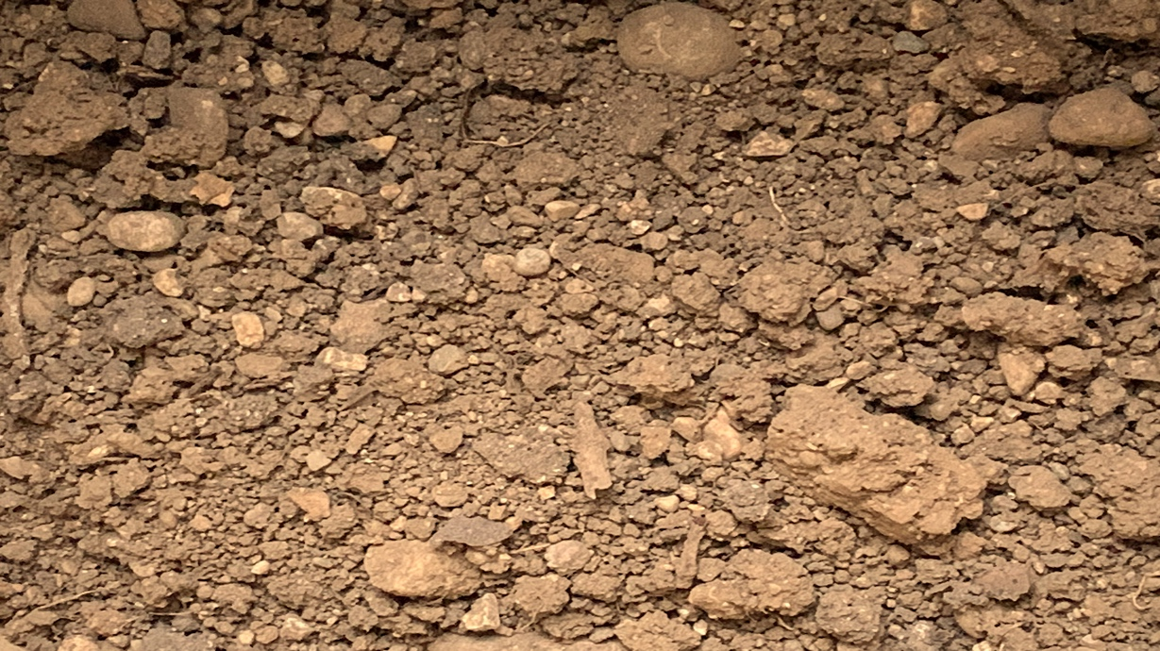

**fig S.1. Turner site sediment sample (0.57-0.58 mbs), which contained pebble size pallasites anomalous levels of Pt, Ir, and mircospherules.** Kenneth Barnett Tankersley used Microsoft PowerPoint for Mac Version 16.41 (www.microsoft.com) to create this figure.

**table S3. Radiocarbon ages for the Jennison-Guard village site, Dearborn County, Indiana.**

|  |  |  |  |
| --- | --- | --- | --- |
| **Sample**  **Composition** | **Lab**  **Number** | **14C Age**  **(yr. B.P.)** | **Calibrated Age**  **yr. B.P.**  **(Probability)1** |
| Hardwood Charcoal | Beta-133997 | 1650 + 50 | 1694-1666 (7.1%)  1624-1404 (88.4%) |
| Carbonized Grape Seed | Beta-133995 | 1710 + 50 | 1717-1516 (94.3%)  1484-1477 (0.4%)  1433-1422 (0.7%) |
| Wood Charcoal | Beta-133998 | 1740 + 50 | 1726-1533 (95.4%) |
| Wood Charcoal | Beta-145867 | 1780 + 50 | 1818-1810 (0.9%)  1791-1760 (3.8%)  1750-1544 (90.8%) |
| Carbonized Grape Seed | Beta-133996 | 1790 + 50 | 1821-1567 (95.4%) |
| Bone Collagen | Beta-237345 | 1820 + 40 | 1827-1690 (69.9%)  1673-1613 (25.5%) |
| Wood Charcoal | Beta-145866 | 1850 ± 50 | 1855-1692 (85.1%)  1671-1619 (10.4%) |
| **Airburst Proxy Stratum Average (239-339 CE)** | | **1770 + 17** | **1712-1612 (95.4%)** |

1. Oxcal Calibration Program 4.3.



**fig. S2. Bayesian adjustments of the radiocarbon ages for the Turner earthworks and village site, Hamilton County, Ohio.** Kenneth Barnett Tankersley used the used the IntCal20 calibration curve in the OxCal 4.4 computer program for Bayesian statistical analysis (https://c14.arch.ox.ac.uk/oxcal.html) to create this figure.

**table S4. Typological ages for the Turner earthworks and village site, Hamilton County, Ohio.**

|  |  |  |  |
| --- | --- | --- | --- |
| **Depth**  **(m)** | **Artifact Type** | **Cultural Period** | **Age** |
| 0.00-0.24 | Glazed Earthenware  Earthenware Bricks | Historic | 1793 to 2020 CE |
| 0.25-0.57 | Snyders Bifaces  Microblades  Microblade Cores  Cut Mica  Earthenware Figurines  Hopewell Pottery | Middle Woodland  (Hopewell Cultural Complex) | 239 to 339 CE |
| 0.58-1.50 | Clovis Biface | Early Paleoindian  (Clovis Cultural Complex) | ~11,000 BCE |
| 1.50-1.78 | Mammoth (*Mammuthus sp.)*  Molar | Pre-habitation | ~13,000 BCE |

**table S5. Chronostratigraphy and Pt and Ir values for the Turner earthworks and village site, Hamilton County, Ohio.**

|  |  |  |  |  |  |
| --- | --- | --- | --- | --- | --- |
| **Depth**  **(m)** | **Composition** | **Munsell Soil Color** | **Age** | **Pt**  **(ppb)** | **Ir**  **(ppb)** |
| 0.00-0.24 | Dark, grayish brown dry, friable, loam with a moderately fine granular structure, slightly alkaline with a smooth and abrupt to boundary. | 10YR 3/2 | 1793 to 2020 CE | - | - |
| 0.25-31 | Brown to dark yellowish brown, friable, silty clay loam with gravel and a moderate to medium subangular blocky structure, mildly alkaline and slightly effervescence, with a smooth clear boundary. | 10YR 4/3-4/4 | 239-339CE | 1.03 | 0.14 |
| 0.32-56 | 0.96 | 0.19 |
| 0.57-0.58 | 6.23 | 1.08 |
| 0.58-1.50 | Brown, friable, sandy loam with gravel, massive structure, mildly alkaline and strongly effervescence, with a clear wavy boundary. | 10YR 4/3 | ~11,000 BCE | - | - |
| 1.50-1.78 | Brown, friable, gravelly, loamy, sand, massive structure, moderately alkaline and slightly effervescence, with a clear boundary | 10YR 5/3 | ~13,000 BCE | - | - |

*3.2 Moundview Village and Mound*

Moundview is a small Hopewell village and mound site (~1.4 ha) located on a narrow late Pleistocene (Wisconsin) terrace remnant overlooking Ragland Creek, a tributary of McCullough Run (S9). It is located ~3 km south of the Little Miami River and ~5.6 km southwest of the Turner site in Anderson Township, Hamilton County, Ohio (S13). Moundview is underlain by upper Ordovician limestone and shale and late Pleistocene glacial outwash. The composition of the glacial outwash is identical to that found at the nearby Turner site. A large earthen mound and portions of the village were built on T1 (~ 198 m amsl) (S1). The village surface consists of a carbon-rich, fire-hardened clay, with wood charcoal, and a midden of flaked-stone artifacts including microblades, Snyder’s bifaces, and Hopewell pot sherds. The burning event occurred sometime between 2021 and 1621 B.P.(1-400 CE).



**fig. S3. Scanning electron micrographs of Fe and Si-rich microspherules from the Moundview village and mound site, Hamilton County, Ohio.** Kenneth Barnett Tankersley used Microsoft PowerPoint for Mac Version 16.41 (www.microsoft.com) to create this figure.

**table S6. Typological ages for the Moundview village and mound site, Hamilton County, Ohio.**

|  |  |  |  |
| --- | --- | --- | --- |
| **Depth (m)** | **Artifact Type** | **Cultural Period** | **Age** |
| 0.00-0.11 | Glazed Earthenware | Historic | 1793 to 2020 CE |
| 0.11-0.12 | Snyders Biface  Microblades  Hopewell Pottery | Middle Woodland  (Hopewell Cultural Complex) | 1-400 CE |
| 0.12-0.20 |
| 0.20-0.32 |
| 0.33-0.50 | Clovis Biface | Early Paleoindian  (Clovis Cultural Complex) | ~11,000 BCE |

**table S7. Chronostratigraphy and Pt and Ir values for the Moundview village and mound site, Hamilton County, Ohio.**

|  |  |  |  |  |  |
| --- | --- | --- | --- | --- | --- |
| **Depth**  **(m)** | **Composition** | **Munsell Soil Color** | **Age** | **Pt**  **(ppb)** | **Ir**  **(ppb)** |
| 0.00-0.11 | Dark grayish brown, dry, friable, loam with a moderate to medium granular structure, which is slightly acidic, with an abrupt smooth boundary. | 10YR 4/2 | 1793 to 2020 CE | - | - |
| 0.11-0.12 | Dark yellowish brown, friable, silty clay loam with a moderately fine to medium subangular blocky structure, medium acidic, with a clear smooth boundary. | 10YR 6/4 | 1-400 CE | 1.46 | 0.14 |
| 0.12-0.20 | 1.14 | 0.19 |
| 0.20-0.32 | 3.70 | 1.08 |
| 0.33-0.50 | Yellowish brown, firm, silty, sandy, clay loam with a medium subangular blocky structure, medium acidic, with a gradual wavy boundary. | 10YR 5/4 | 11,000 BCE | - | - |

*3.3 Jennison Guard Village*

The Jennison-Guard village site, also known as the Guard South and Whitacre site, is a ~20 ha Middle Woodland cultural period village site (~143 m amsl) located on the late Holocene floodplain (T0) of the Great Miami-Ohio River confluence, in Dearborn County, Indiana (S14, S15, S16, S17, S18, S19, S20). The village site is deeply stratified with a 0.6-0.7 m thick village midden buried beneath 0.30-1.45 m of sterile post-habitation alluvium. The midden is densely filled with discarded household food (i.e., the remains of carbonized plants, freshwater mussels, and vertebrates) and manufacturing debris (S19). Like the Turner earthworks and village site, the remains of rectangular habitation structures appear as carbonized wood, daub, with impressions of carbonized thatch, and post holes in a fire-hardened surface. The burning event occurred sometime between 1691 and 1541 B.P. (259-410 CE). Temporally distinctive Hopewell Cultural Complex flaked-stone (e.g., microblades, Snyder’s and Lowe-flared based bifaces, microblades) and ceramic artifacts (e.g., quadruped vessels, grit and limestone tempered earthenware) co-occur with an abundance of cut mica (i.e., biotite and muscovite) from sources ~500 km from the site (S16, S16). Although three burial mounds occur in the immediate vicinity, their temporal and spatial relationship with the village is unknown (S14).



**fig. S4. Scanning electron micrographs of Fe and Si-rich microspherules from the Jennison-Guard village site, Dearborn County, Indiana.** Kenneth Barnett Tankersley used Microsoft PowerPoint for Mac Version 16.41 (www.microsoft.com) to create this figure.

**table S8. Radiocarbon ages for the Jennison-Guard village site, Dearborn County, Indiana (S15, S16, S17, S18, S19, S20).**

|  |  |  |  |
| --- | --- | --- | --- |
| **Sample**  **Composition** | **Lab**  **Number** | **14C Age**  **(yr. B.P.)** | **Calibrated Age**  **yr. B.P.**  **(Probability)1** |
| Collagen | Beta-547669 | 1630 + 30 | 1568-1409 (95.4%) |
| Hardwood Charcoal | Beta-67622 | 1660 + 70 | 1705-1398 (95.4.%) |
| Hardwood Charcoal | Wis-1745 | 1660 + 70 | 1705-1398 (95.4.%) |
| Collagen | Beta-547668 | 1680 + 30 | 1695-1665 (13.8%)  1625-1518 (81.7%) |
| Hardwood Charcoal | Beta-547670 | 1730 + 30 | 1703-1652 (32.6%)  1645-1544 (62.9%) |
| Collagen | Beta-547667 | 1740 + 30 | 1705-1549 (95.4%) |
| Hardwood Charcoal | Wis-1744 | 1800 + 70 | 1870-1851 (1.8%)  1841-1537 (93.6%) |
| Hardwood Charcoal | Wis-1746 | 1810 + 70 | 1874-1542 (95.4%) |
| **Airburst Proxy Stratum Average (259-410 CE)** | | **1703 + 15** | **1691-1541 (95.4%)** |
| **Base of the Stratum** | | | |
| Pottery | UGa-53454 | 1930 + 25 | 1926-1776 (89.5%)  1770-1746 (6%) |

1. Oxcal Calibration Program 4.4.



**fig. S5. Bayesian adjustments of the radiocarbon ages for the Jennison-Guard village site, Dearborn County, Indiana.** Kenneth Barnett Tankersley used the used the IntCal20 calibration curve in the OxCal 4.4 computer program for Bayesian statistical analysis (https://c14.arch.ox.ac.uk/oxcal.html) to create this figure.

**table S9. Typological ages for the Jennison-Guard village site, Dearborn County, Indiana.**

|  |  |  |  |
| --- | --- | --- | --- |
| **Depth (m)** | **Artifact Type** | **Cultural Period** | **Age** |
| 0.00-0.38 | Glazed Earthenware  Salt-glazed Pottery  Glass | Historic | 1793 to 2020 CE |
| 0.38-0.55 | Snyders Biface  Microblades  Cut Mica  Hopewell Pottery | Middle Woodland  (Hopewell Cultural Period) | 1-400 CE |
| 0.55-1.25 |
| 1.25-1.40 |
| 1.40-1.57 | - | Pre-habitation | Pre-400 CE |
| 157-1.60 | - |

**table S10. Chronostratigraphy and Pt and Ir values for the Jennison-Guard village site, Dearborn County, Indiana.**

|  |  |  |  |  |  |
| --- | --- | --- | --- | --- | --- |
| **Depth**  **(m)** | **Composition** | **Munsell Soil Color** | **Age** | **Pt**  **(ppb)** | **Ir**  **(ppb)** |
| 0.00-0.38 | Brown, very friable, silt loam with a weakly fine granular structure, slightly acidic, and an abrupt smooth boundary. | 10YR 4/3 | 1793 to 2020 CE | - | - |
| 0.38-0.55 | Brown, very friable, laminated silt loam, with a weak fine granular structure, slightly acidic, and a gradual smooth boundary. | 10YR 4/3 | 259-410 CE | 1.88 | 0.38 |
| 0.55-1.25 | Brown, very friable, laminated silt loam, with a weak fine granular structure, slightly acidic, and a gradual smooth boundary. | 10YR 4/3 | 0.49 | 0.19 |
| 1.25-1.40 | Brown, very friable, fine sandy silt loam with a weakly medium subangular blocky structure, slightly acidic, and a gradual smooth boundary. | 10YR 4/3-10YR 4/4 | 0.46 | 0.17 |
| 1.40-1.57 | Brown, very friable, massive, silty clay loam, slightly acidic, and a gradual smooth boundary. | 10YR 4/3-10YR 4/4 | 259-410 CE | - | - |
| 1.57-1.60 | Brown, very friable, massive, clay loam with thin strata of loam and silty clay loams, slightly acidic, and a gradual smooth boundary. | 10YR 4/3-10YR 4/4 | Pre-410 CE | - | - |

*3.4 Miami Fort Earthworks and Village*

Miami Fort is ~13 ha village site within a hilltop enclosure, ~227 m amsl, and situated on a high Illinoisan terrace, which forms an elongated ridge overlooking the Great Miami-Ohio River confluence area in Hamilton County, Ohio (S13). The hilltop earthworks were constructed to enclose a 5.7 km2 watershed, which drew from a natural rainfall catchment area with reservoirs built along the extreme margins of the ridgetop (S21). The earthworks include a graded causeway (~900 m length, ~20 m height), more than five kilometers of earthen berms (~0.5-5.0 m height, 12 m width), deep sluiceways (~2.5 m), which drained into reservoirs with log and clay dams (S21). The volume of the reservoirs ranged from ~62 m3 to > 1200 m3 of water. The site is well stratified with a 24-30 cm thick midden deposit buried beneath 0.23-0.36 m of post-habitation silt loam. The midden contains plant (carbonized plant remains) and animal food (vertebrate remains) waste and lithic fabrication (flaked-stone and ground-stone) debris. Temporally distinctive Hopewell artifacts include Synder bifaces, microblades, Hopewell earthenware vessels, and obsidian from a source ~2,000 km from the site. The upper habitation surface is carbon-rich and fire-hardened with the remains of burned structures including carbonized timbers and post molds. The burning event occurred sometime between 1877-1333cal yr B.P. (74-618 CE).



**fig. S6. Scanning electron micrographs of Fe and Si-rich microspherules from the Miami Fort earthworks village site, Hamilton County, Ohio.** Kenneth Barnett Tankersley used Microsoft PowerPoint for Mac Version 16.41 (www.microsoft.com) to create this figure.

**table S11. Radiocarbon ages for Miami Fort earthworks and village site, Hamilton County, Ohio (S21 and this paper).**

|  |  |  |  |
| --- | --- | --- | --- |
| **Sample**  **Composition** | **Lab**  **Number** | **14C Age**  **(yr. B.P.)** | **Calibrated Age**  **yr. B.P.**  **(Probability)1** |
| **Overlying Strata** | | | |
| Collagen | Beta-538688 | 113 + 0.4 | 258-224 (25%)  140-32 (71%) |
| Collagen | Beta-538687 | 115 + 0.4 | 258-223 (23%)  140-55 (60%)  49-32 (13%) |

|  |  |  |  |
| --- | --- | --- | --- |
| Hardwood Charcoal | Beta-248352 | 240 + 40 | 435-360 (15%)  330-260 (40%)  223-141 (34%)  29 (6%) |
| Hardwood Charcoal | Beta-249682 | 270 + 40 | 461-275 (85%)  208-200 (1%)  186-151 (9%) |
| Hardwood Charcoal | Beta-249597 | 1360 + 40 | 1347-1244 (75%)  1214-1176 (21%) |
| **Airburst Proxy Stratum (1867-1310 B.P., 116-641 CE)** | | | |
| Hardwood Charcoal | M-1869 | 1680 + 130 | 1867-1855 (1%)  1835-1310 (95%) |
| **Underlying Stratum** | | | |
| Hardwood Charcoal | Beta-247820 | 2030 + 40 | 2012-1871 (95%)   * 1. (1%) |

1. Oxcal Calibration Program 4.4.



**fig. S7. Bayesian adjustments of the radiocarbon ages using OXCAL 4.4 to give the full range of possible ages for the Miami Fort earthworks and village site, Hamilton County, Ohio.** Kenneth Barnett Tankersley used the used the IntCal20 calibration curve in the OxCal 4.4 computer program for Bayesian statistical analysis (https://c14.arch.ox.ac.uk/oxcal.html) to create this figure.

**table S12. Typological ages for the Miami Fort earthworks and village site, Hamilton County, Ohio.**

|  |  |  |  |
| --- | --- | --- | --- |
| **Depth (m)** | **Artifact Type** | **Cultural Period** | **Age** |
| 0.00-0.20 | Glazed Earthenware  Glass | Historic | 1793 to 2020 CE |
| 0.20-0.65 | Snyders Biface  Microblades  Hopewell Pottery  Obsidian | Middle Woodland  (Hopewell Cultural Complex) | 1 to 400 CE |
| 0.65-0.95 | Adena Pottery  Adena-stemmed Biface | Early Woodland  (Adena Cultural Complex | 1000 BCE to 1 CE |
| 0.95-1.00 | McWhinney Biface | Late Archaic | 3000 to 1000 BCE |

**table S13. Chronostratigraphy and Pt and Ir values for the Miami Fort earthworks and village site, Hamilton County, Indiana.**

|  |  |  |  |  |  |
| --- | --- | --- | --- | --- | --- |
| **Depth**  **(m)** | **Composition** | **Munsell Soil Color** | **Age** | **Pt**  **(ppb)** | **Ir**  **(ppb)** |
| 0.00-0.20 | Grayish brown, dry, friable, silt loam with a weak fine to medium granular structure, medium acidic, and an abruptly smooth boundary. | 10YR 4/2-10YR 6/2 | 1793 to 2020 CE | - | - |
| 0.20-0.36 | Brown, friable, silt loam with a thin weakly platy structure, strongly acidic, and a clear wavy boundary. | 10YR 5/3 | 116-641 CE | 1.88 | 0.35 |
| 0.36-0.45 | Strong brown, friable, silt loam, with a moderately fine subangular blocky structure, very strongly acidic, and a clear wavy boundary. | 7.5YR 5/6 | 1.41 | 0.38 |
| 0.45-0.65 | Strong brown, friable, silty clay loam, with a moderately to medium subangular blocky structure, very strongly acidic, and a clear wavy boundary. | 7.5YR 5/6 | 1.33 | 0.36 |
| 0.65-0.95 | Strong brown, friable, silty clay loam, with a moderately to medium subangular blocky structure, very strongly acidic, and a clear wavy boundary. | 7.5YR 5/6 | 259-410 CE | - | - |
| 0.95-1.00+ | Yellowish red, firm, clay loam, with a strong subangular blocky structure, very strongly acidic, and a diffuse wavy boundary. | 5YR 4/6 | Pre-410 CE | - | - |

**table S14. Stable carbon isotope analysis of a Miami Fort earthworks Middle Woodland cultural period reservoir, Hamilton County, Indiana.**

|  |  |  |  |  |
| --- | --- | --- | --- | --- |
| **Depth**  **(cm)** | ** 13C**  **(‰)** | **Mass Fraction C (%)** | **Standard Deviation** | **Cultural Period** |
| 2.8 | -25.97 | 3.03 | 0.13 | Historic |
| 5.6 | -25.69 | 2.57 | 0.05 |
| 8.4 | -24.39 | 2.53 | 0.08 | Fort Ancient |
| 11.2 | -24.57 | 1.42 | 0.12 |
| 14.0 | -25.08 | 1.21 | 0.02 |
| 16.8 | -25.54 | 1.17 | 0.01 |
| 19.6 | -25.76 | 1.23 | 0.07 |
| 22.4 | -26.45 | 2.19 | 0.01 | Late Woodland |
| 25.2 | -26.26 | 2.32 | 0.18 |
| 28.0 | -25.71 | 1.62 | 0.02 |
| 30.8 | -25.26 | 0.94 | 0.17 |
| 33.6 | -26.03 | 1.35 | 0.14 |
| 36.4 | -25.56 | 0.97 | 0.04 |
| 39.2 | -24.81 | 0.57 | 0.10 |
| 42.0 | -24.64 | 0.46 | 0.10 |
| 44.8 | -24.43 | 0.42 | 0.05 |
| 47.6 | -24.38 | 0.36 | 0.01 |
| 50.4 | -23.76 | 0.28 | 0.15 | Middle Woodland |
| 53.2 | -24.18 | 0.26 | 0.08 |
| 56.0 | -24.77 | 0.32 | 0.22 |
| **International Isotopic Reference Materials Used for Normalization** | | | | |
| USGS40 | -26.39 | - | 0.03 | Modern |
| USGS41a | -36.55 | - | 0.11 | Modern |

*3.5 Beech Tree Village*

Beech Tree is a small Hopewell village site (~1.0 ha) located on a high, late Pleistocene (Illinoian) terrace remnant, which forms a narrow ridgetop (208.79 m amsl), overlooking Salt Run Creek (320 m distance, 60 m elevation above), a tributary of the Little Miami river. It is located ~1.46 km south of the East Fork of the Little Miami River and ~5.0 km southeast of the Milford Earthworks site in Clermont, Ohio (S22). Beech Tree is underlain by Illinoian glacial till and outwash, which forms a coarse-grained cemented conglomerate. The village surface is an oxidized, fire-hardened, carbon-rich clay with wood charcoal and a thin midden of flaked-stone manufacturing debris including non-local Wyandotte and Zaleski cherts, microblades, and Snyder’s bifaces. The burning event dates to sometime between 2021 and 1621 B.P. (1-400 C.E.).

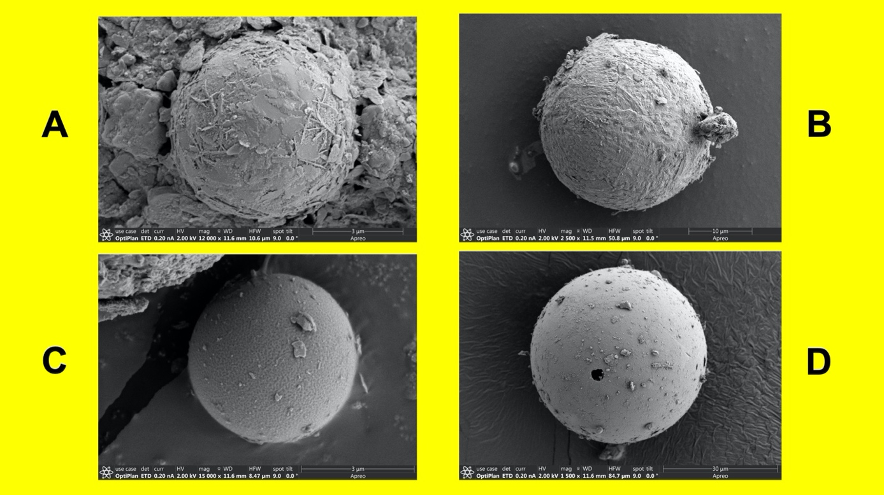

**fig. S8. Scanning electron micrographs of Fe and Si-rich microspherules from the Beech Tree village site, Clermont County, Ohio.** Kenneth Barnett Tankersley used Microsoft PowerPoint for Mac Version 16.41 (www.microsoft.com) to create this figure.

**table S15. Typological ages for the Beech Tree village site, Clermont County, Ohio.**

|  |  |  |  |
| --- | --- | --- | --- |
| **Depth**  **(m)** | **Artifact Type** | **Cultural Period** | **Age** |
| 0.00-0.14 | Glazed Earthenware  Glass | Historic | 1793 to 2020 CE |
| 0.14-0.30 | Snyders Biface  Microblades | Middle Woodland  (Hopewell Cultural Complex) | 1-400 CE |
| 12-20 |
| 20-32 |
| 0.33-0.50 | - | Pre-habitation | Pre-400 CE |

**table 16. Chronostratigraphy and Pt and Ir values for the Beech Tree village, Clermont County, Ohio.**

|  |  |  |  |  |  |
| --- | --- | --- | --- | --- | --- |
| **Depth**  **(m)** | **Composition** | **Munsell Soil Color** | **Age** | **Pt**  **(ppb)** | **Ir**  **(ppb)** |
| 0.00-0.14 | Dark yellowish brown, friable, dry, silt loam with a fine granular structure, strongly acidic, and a clear smooth boundary. | 10YR 3/4 | 1793 to 2020 CE | - | - |
| 0.14-0.40 | Strong brown, friable, silty clay loam, moderate to medium subangular blocky structure, very strongly acidic, with a clear wavy boundary. | 7.5YR 5/8 | 1-400 CE | 0.33 | 0.04 |
| 0.40-0.60 | 1.44 | 0.26 |
| 0.60-0.75 | 1.60 | 0.34 |
| 0.75-1.00+ | Strong Brown, firm, mottled, clay loam, moderately very coarse prismatic structure parting to weak medium subangular blocky strongly acidic, with a clear wavy boundary. | 7.5YR 5/6 | Pre-400 CE | - | - |

*3.6 Milford Earthworks (Comet Earthwork)*

The Milford Earthworks includes one of the most extensive geometric complexes in the Ohio River valley (S22). The uppermost complex includes a comet-shaped earthwork, which covers ~3.90 ha, ~3 km northeast of the confluence of the east and west forks of Little Miami River and ~17 kilometers northeast of the Little Miami-Ohio River confluence. The Milford Earthworks were first mapped by William Lytle in 1803 during his post-Revolutionary War survey of Clermont County, Ohio (S22). The comet-shaped portion of the earthworks is underlain by upper Ordovician limestone and shale and late Pleistocene glacial outwash (coarse gravel and sand). The earthwork was constructed on the surface of a late Pleistocene terrace (T3), which is ~16.7 m above a broad underfit floodplain and boarders a former stream bed of the East Fork of the Little Miami River (S22). A ~25 cm thick heavily burned stratum occurs between 0.75 and 1.00 m below the present surface. The occurrence of Hopewell microblades and microblade core in this stratum suggest that the burning event occurred sometime between 1 and 400 CE.

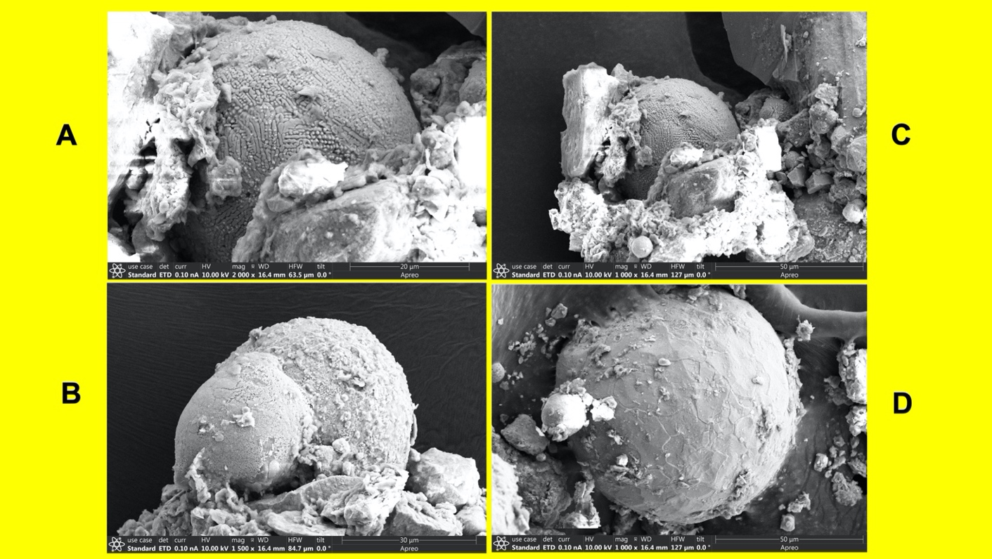

**fig. S9. Scanning electron micrographs of Fe and Si-rich microspherules from the Milford Earthwork site, Clermont County, Ohio.** Kenneth Barnett Tankersley used Microsoft PowerPoint for Mac Version 16.41 (www.microsoft.com) to create this figure.

**table S17. Typological ages for the Milford Earthworks, Clermont County, Ohio.**

|  |  |  |  |
| --- | --- | --- | --- |
| **Depth**  **(m)** | **Artifact Type** | **Cultural Period** | **Age** |
| 0.0-0.20 | Glass  Iron | Historic | 1793 to 2021 CE |
| 0.20-0.25 |
| 0.25-0.38 |
| 0.38-0.57 |
| 0.57-0.74 |

|  |  |  |  |
| --- | --- | --- | --- |
| 0.74-0.89 | Microblade  Microblade Core | Middle Woodland | 1-400 CE |
| 0.89-1.52+ | - | Pre-habitation | 18,560–25,520 B.P. |

**table S18. Chronostratigraphy and Pt and Ir values for the Milford Earthworks, Clermont County, Ohio.**

|  |  |  |  |  |  |
| --- | --- | --- | --- | --- | --- |
| **Depth**  **(m)** | **Composition** | **Munsell Soil Color** | **Age** | **Pt**  **(ppb)** | **Ir**  **(ppb)** |
| 0.0-0.20 | Brown, dry, friable, loam with a weak fine granular structure, slightly acidic, and an abrupt smooth boundary. | 7.5 YR 4/2 | 1793 to 2021 CE | - | - |
| 0.20-0.25 | Brown, friable, loam with a weak, medium to coarse subangular blocky structure, slightly acidic, and a clear wavy boundary. | 7.5 YR 4/4 | - | - |
| 0.25-0.38 | Brown, friable, sandy clay loam with a medium subangular blocky structure, slightly acidic, and a gradual wavy boundary. | 7.5 YR 4/4 | - | - |
| 0.38-0.57 | Dark reddish brown, firm, clay with a moderate to medium subangular blocky structure, neutral, with an abrupt wavy boundary. | 5 YR 3/4 | - | - |
| 0.57-0.74 | Dark reddish brown, firm, clay with a moderate to medium subangular blocky structure, neutral, with an abrupt wavy boundary. | 5 YR 3/3 | - | - |
| 0.74-0.89 | Dark reddish brown, gravely loamy sand, strongly effervescence, moderately alkaline, and an abrupt boundary | 5 YR 3/3 | 1-400 CE | 1.01 | 0.32 |
| 0.89-1.52+ | Brown, loose, gravel and sand, strongly effervescence, moderately alkaline, and an abrupt boundary. | 7.5 YR 4/4 | 16,539–23,499 BCE | - | - |

*3.7 Indian Fort Earthwork*

The Indian Fort Mountain earthwork is a ~25 ha hilltop enclosure located in the Knobs region of Madison County, Kentucky (S23, S24, S25, S26). The enclosure consists of stone and earthen berms, one to two meters high, along the margins of a flat-topped, steep-sided, erosional remnant known variously as a monadnock, butte, and stratigraphic outlier. The earthwork is underlain by massive, cliff-forming beds of Pennsylvanian age conglomerate sandstone and cavernous Mississippian limestone. Mississippian and Devonian shales form the steep slopes at the base of the resistant sandstone and limestone caprocks. Like other hilltop enclosures, the Indian Fort earthwork likely functioned as a water management system (S21, S27). Hopewell Cultural Complex artifacts include Snyder’s bifaces and copper gorgets (S23, S24, S24, S26). The Middle Woodland cultural period stratum consists of a carbon-rich, fire-hardened, fine sandy stratum with abundant wood charcoal above a dense oxidized clayey sand. The burning event post-dates 1990-1706 B.P., or sometime after 41 BCE to 245 C.E.



**fig. S10. Scanning electron micrographs of Fe and Si-rich microspherules from the Indian Fort Mountain earthworks site, Madison County, Kentucky.** Kenneth Barnett Tankersley used Microsoft PowerPoint for Mac Version 16.41 (www.microsoft.com) to create this figure.

**table S19. Radiocarbon ages for the underlying strata at the Indian Fort Mountain earthworks, Madison County, Kentucky (S28).**

|  |  |  |  |  |
| --- | --- | --- | --- | --- |
| **Sample**  **Composition** | **Lab**  **Number** | **14C Age**  **(yr. B.P.)** | **Calibrated Age**  **yr. B.P.**  **(Probability)1** | **References** |
| **Airburst Proxy Stratum (post-dates 41 BCE-245 CE) post-dates 1990-1706 B.P.** | | | | |
| **Underlying Strata** | | | | |
| Hardwood  Charcoal | Beta-2862 | 1910 + 60 | 1990-1958 (4%)  1950-1706 (91%) | Moore, 1982 |
| Hardwood  Charcoal | Beta-2861 | 2530 + 130 | 2926-2901 (1%)  2884-2321 (95%) | Moore, 1982 |

1. Oxcal Calibration Program 4.4.



**fig. S11. Bayesian adjustments of the radiocarbon ages for the underlying strata at the Indian Fort Mountain earthworks site, Madison County, Kentucky.** Kenneth Barnett Tankersley used the used the IntCal20 calibration curve in the OxCal 4.4 computer program for Bayesian statistical analysis (https://c14.arch.ox.ac.uk/oxcal.html) to create this figure.

**table S20. Typological ages for the Indian Fort Mountain earthworks, Madison County, Kentucky.**

|  |  |  |  |
| --- | --- | --- | --- |
| **Depth**  **(m)** | **Artifact Type** | **Cultural Period** | **Age** |
| 0.00-0.07 | Glass | Historic | 1950 to 2020 CE |
| 0.07-0.22 | Microblades,  Copper Gorget | Middle Woodland  (Hopewell Cultural Complex) | 1-400 CE |
| 0.22-0.33 | - | - | - |
| 0.33-0.60 | - | Pre-habitation | - |

**table S21. Chronostratigraphy and Pt and Ir values for the Indian Fort Mountain earthworks, Madison County, Kentucky.**

|  |  |  |  |  |  |
| --- | --- | --- | --- | --- | --- |
| **Depth**  **(m)** | **Composition** | **Munsell Soil Color** | **Age** | **Pt**  **(ppb)** | **Ir**  **(ppb)** |
| 0.00-0.07 | Brown, friable, sandy loam with a weakly fine granular structure; non-sticky and non-plastic with angular and subangular channers, strongly acid, and a clear smooth boundary. | 7.5YR 4/4 | 1950 to 2020 CE | - | - |
| 0.07-0.07 | Pink, friable, sandy loam with a weakly fine subangular blocky structure, non-sticky and non-plastic, strongly acid, with a gradual wavy boundary | 7.5YR 7/4 | post 41 BCE to 245 CE | 0.30 | 0.04 |
| 0.07-0.09 | 0.71 | 0.15 |
| 0.09-0.12 | 0.89 | 0.21 |
| 0.12-0.33 | 0.73 | 0.30 |
| 0.33-0.45 | Very dark brown, friable clayey sand, massive, non-sticky and non-plastic, very strongly acid, and a clear wavy boundary. | 7.5YR 2.5/2 | 41 BCE to  245 CE | - | - |
| 0.45-0.60 | Very dark brown, silty sand with interstitial pores and a massive fine-grained sandstone bedrock-controlled structure. | 7.5YR 2.5/3 | 977 BCE to  372 BCE | - | - |

*3.8 Fosters Crossing Earthwork*

Fosters Crossing is a hilltop enclosure overlooking the Little Miami River valley in Warren County, Ohio (S29, S30). It is underlain by late Pleistocene (Illinoian) glacial till and Upper Ordovician limestone and shale. The earthwork is ~1.0 km in length, ~0.2 to 4 m high, and up to ~17 m wide. The foundation of the earthwork is composed of local fossiliferous limestone, which has been covered by clayey loam derived from the underlying glacial till. The earthwork is carbon-rich and fire-hardened with large masses of wood charcoal and ash. In some places the limestone has been thermally reduced to lime (S29). The clay shows evidence of having been exposed to extreme heat including areas that are “vitreous” with “great masses of slag” that resemble “that from a blast furnace” (S29, S30). This burning event dates sometime between ~1 and 400 CE. A habitation area occurs within the enclosure and includes a midden with typologically distinctive Snyder’s bifaces, microblades, and Hopewell pottery.



**fig. S12 Scanning electron micrographs of Fe and Si-rich microspherules from the Fosters Crossing earthworks site, Warren County, Ohio.** Kenneth Barnett Tankersley used Microsoft PowerPoint for Mac Version 16.41 (www.microsoft.com) to create this figure.

**table S22. Typological ages for the Fosters Crossing Earthworks site, Warren County, Ohio.**

|  |  |  |  |
| --- | --- | --- | --- |
| **Depth**  **(m)** | **Artifact Type** | **Cultural Period** | **Age** |
| 0.00-0.15 | Glazed Earthenware  Glass | Historic | 1793 to 2020 CE |
| 0.15-0.25 |
| 0.25-0.40 | Snyders bifaces,  microblades,  Hopewell pottery | Middle Woodland  (Hopewell Cultural Complex) | 1-400 CE |
| >0.40 | - | Pre-habitation | Pre-400 CE |

**table S23. Chronostratigraphy and Pt and Ir values for the Fosters Crossing earthwork, Warren County, Ohio.**

|  |  |  |  |  |  |
| --- | --- | --- | --- | --- | --- |
| **Depth**  **(m)** | **Composition** | **Munsell Soil Color** | **Age** | **Pt**  **(ppb)** | **Ir**  **(ppb)** |
| 0.00-0.15 | Brown, friable, silt loam brown silt loam, with a weakly medium to fine subangular blocky structure, moderately acidic, and an abrupt wavy boundary. | 10YR 5/3 | 1793 to 2020 CE | - | - |
| 0.15-0.25 | Dark yellowish brown, friable, silty clay loam, with a moderately medium to fine subangular blocky structure, strongly acid, and a clear wavy boundary. | 10YR 4/4 | - | - |
| 0.25-0.40 | Brown, firm, silty clay with a moderate medium subangular blocky structure, with limestone fragments, neutral to slightly alkaline, and a clear wavy boundary. | 10YR 4/3 | 1-400 CE | 0.77 | 0.24 |
| >0.40 | Yellowish brown, firm, clay with a weakly medium subangular blocky structure, limestone fragments, slightly alkaline, and a clear wavy boundary. | 10YR 5/4 | Pre-400 CE | - | - |

*3.9 Krasnosky Earthworks*

The Krasnosky earthworks are a ~3 ha hilltop enclosure located on a narrow, heavily dissected, ridge in the unglaciated region of Hocking County, Ohio. Krasnosky is the southeastern most hilltop enclosure in Ohio and one of five known in the Hocking River drainage. The earthwork was built on top of the erosional resistant Mississippian age Black Hand sandstone caprock with the underlying Mississippian Fairfield shale and sandstone forming steep, adjacent slopes (S31). The enclosure consists of a stone and earthen berm, up to one meter high, and an adjacent ditch, up to a meter in depth. Like the Indian Fort earthwork, and other hilltop enclosures in the Ohio River valley, Krasnosky likely functioned as a water management system (S21, S27). Hopewell Cultural Complex microblades occur in the sediments of the berm and ditch. The Middle Woodland cultural period stratum consists of a carbon-rich, fire-hardened, silty, sandy, clay stratum with abundant wood charcoal above a dense oxidized clayey sand. The burning event dates sometime between 1 and 400 CE.

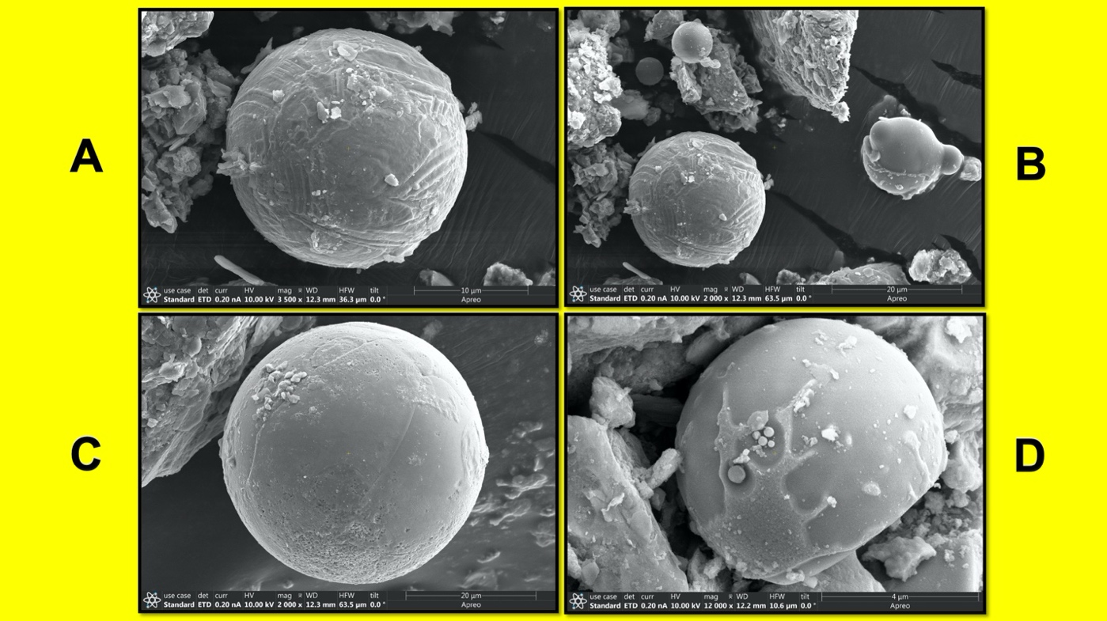

**fig. S13.** **Scanning electron micrographs of Fe and Si-rich microspherules from the Krasnosky earthworks, Hocking County, Ohio.** Kenneth Barnett Tankersley used Microsoft PowerPoint for Mac Version 16.41 (www.microsoft.com) to create this figure.

**table S24. Typological ages for the Krasnosky earthworks, Hocking County, Ohio.**

|  |  |  |  |
| --- | --- | --- | --- |
| **Depth**  **(m)** | **Artifact Type** | **Cultural Period** | **Age** |
| 0.00-0.10 | Glass | Historic | 1793 to 2020 CE |
| 0.10-0.27 | Microblades, | Middle Woodland  (Hopewell Cultural Complex) | 1-400 CE |
| 0.27-0.42 |

**table S25. Chronostratigraphy and Pt and Ir values for the Krasnosky earthworks, Hocking County, Ohio.**

|  |  |  |  |  |  |
| --- | --- | --- | --- | --- | --- |
| **Depth**  **(m)** | **Composition** | **Munsell Soil Color** | **Age** | **Pt**  **(ppb)** | **Ir**  **(ppb)** |
| 0.00-0.10 | Brown, friable, silty clay loam with a moderately medium granular structure, slightly acid, and an abrupt smooth boundary. | 10YR 3/2 | 1793 to 2020 CE | 0.39 | 0.10 |
| 0.10-0.27 | Yellowish brown, friable, silt loam to a silty clay with a moderately medium to medium subangular blocky structure, neutral to slightly acid, and a clear smooth boundary. | 10YR 5/8 | 1-400 CE | 0.43 | 0.07 |
| 0.27-0.42 | Brownish yellow, friable, silty sandy clay with weak bedding planes, slightly alkaline, and a clear boundary. | 10YR 6/8 | 0.53 | 0.11 |

*3.10 Marietta Earthworks and Mounds*

Marietta is one of the largest earthwork and mound complexes in southeastern Ohio (S22). The Marietta earthworks and mounds are located on a late Pleistocene terrace (Wisconsin) and late Holocene floodplain at the Muskingum and Ohio rivers confluence in Washington County, Ohio (S12, S32). They include Conus, a large conical mound (~9 m) enclosed by a deep trench (~5 m wide, ~1 m deep) and earthen berm (~6 wide, ~180 m circumference), two flat-topped pyramidal-shaped mounds with ramps known as Capitolium (~46 x 40 x 3 m) and Quadranaou (~60 x 11 x 3 m), two large rectangular earthen enclosures (~ 30 ha), and a graded way (>200 m) bounded by earthen walls (~6 m) known as the Sacra Via, which once extended to the Muskingum River (S12, S22, S32). Like the Turner site, “prepared floors” and post holes were found under Capitolium Mound along with an oxidized, fire-hardened, carbon-rich clay with wood charcoal and a plethora of Hopewell pottery, microblades and microblade cores manufactured from Flint Ridge, Upper Mercer, and Zalaski cherts, and mica (S12, S33).

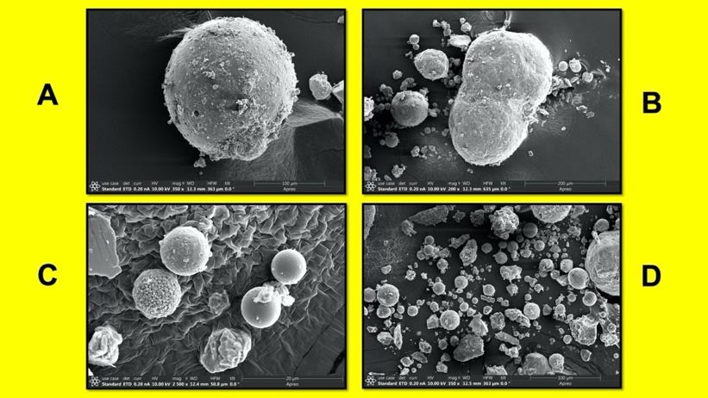

**fig. S14. Scanning electron micrographs of Fe and Si-rich microspherules from the Marietta earthworks and mounds site, Washington County, Ohio.** Kenneth Barnett Tankersley used Microsoft PowerPoint for Mac Version 16.41 (www.microsoft.com) to create this figure.

**table S26. Radiocarbon ages for Marietta earthworks and mound site, Washington County, Ohio (S12, S33).**

|  |  |  |  |
| --- | --- | --- | --- |
| **Sample**  **Composition** | **Lab**  **Number** | **14C Age**  **(yr. B.P.)** | **Calibrated Age**  **yr. B.P.**  **(Probability)1** |
| Honey Locust (*Gleditsia tricanthos*)  Charcoal | Beta-78014 | 1660 + 60 | 1700-1655 (12%)  1640-1404 (84%) |
| Mulberry (*Morus sp.*)  Charcoal | Beta-78012 | 1670 + 60 | 1701-1654 (14%)  1641-1410 (81%) |
| Nut Shell Charcoal | Beta-78013 | 1790 + 50 | 1821-1567 (95%) |
| Hardwood Charcoal | Beta-67234 | 1880 + 70 | 1987-1961 (2%)  1948-1691 (86%)  1671-1616 (7%) |
| **Airburst Proxy Stratum Average (246-401 CE)** | | **1739 + 27** | **1704-1539 (95.4%)** |

1. Oxcal Calibration Program 4.4.



**fig. S15. Bayesian adjustments of the radiocarbon ages for the Marietta earthworks and mounds site, Washington County, Ohio.** Kenneth Barnett Tankersley used the used the IntCal20 calibration curve in the OxCal 4.4 computer program for Bayesian statistical analysis (https://c14.arch.ox.ac.uk/oxcal.html) to create this figure.

**table S27. Typological ages for the Marietta earthworks and mounds site, Washington County, Ohio.**

|  |  |  |  |
| --- | --- | --- | --- |
| **Depth**  **(m)** | **Artifact Type** | **Cultural Period** | **Age** |
| 0.00-0.19 | Glazed Earthenware,  Glass | Historic | 1793 to 2020 CE |
| 0.19-0.21 | Microblades, Hopewell Pottery, Mica | Middle Woodland  (Hopewell Cultural Complex) | 1-400 CE |
| 0.21-0.33 |
| 0.33-0.68 |
| 0.68-0.70 | - | Pre-habitation | Pre-400 CE |

**table S28. Chronostratigraphy and Pt and Ir values for the Marietta Earthworks and Mounds site, Washington County, Ohio.**

|  |  |  |  |  |  |
| --- | --- | --- | --- | --- | --- |
| **Depth**  **(m)** | **Composition** | **Munsell Soil Color** | **Age** | **Pt**  **(ppb)** | **Ir**  **(ppb)** |
| 0.00-0.19 | Very dark brown, friable, sandy loam, moderately medium granular structure, neutral, with an abrupt smooth boundary. | 10YR 2/2 | 1793 to 2020 CE | - | - |
| 0.19-0.21 | Very dark brown, friable to firm, fine sandy loam, with a weakly medium to moderately fine subangular blocky structure, slightly to moderately acidic, and a gradual to clear smooth boundary. | 10YR 2/2 | 246-401 CE | 1.05 | 0.08 |
| 0.21-0.33 | 0.48 | 0.10 |
| 0.33-0.68 | 0.27 | 0.06 |
| 0.68-0.70 | Brown, friable to loose, clayey, silty, sand, moderately to strongly acid, with a gradual wavy boundary. | 10YR 4/3 | Pre-400 CE | - | - |

*3.11 Junction Earthworks and Mounds*

Junction earthworks and mounds cover ~8 ha of a late Pleistocene (Wisconsin) terrace of Paint Creek in Ross County, Ohio (S22, S30). The unusually shaped geometric earthworks consist of a north-facing semicircle of nine individual crescent and rectangular earthen berms and adjacent ditches including one in the shape of a four-leaf clover known as the Quatrefoil (S34). In addition to the earthworks, there are four earthen mounds that range from 1 m to 2 m high and 10 m to 15 m wide with nearly circular earthen berms and a ditch (S22, S30). The anthropogenic surface is a heavily burned, carbon-rich clay with a thick layer (~10 cm) of wood charcoal (S22). Typologically distinctive artifacts including Snyder’s bifaces, microblades, and Hopewell pottery occur in the anthropogenic stratum. The age of the burning event is sometime between 1 and 400 CE.



**fig. S16. Scanning electron micrographs of Fe and Si-rich microspherules from the Junction earthworks and mounds, Ross County, Ohio.** Kenneth Barnett Tankersley used Microsoft PowerPoint for Mac Version 16.41 (www.microsoft.com) to create this figure.

**table S29. Typological ages for the Junction earthworks and mounds site, Ross County, Ohio.**

|  |  |  |  |
| --- | --- | --- | --- |
| **Depth**  **(m)** | **Artifact Type** | **Cultural Period** | **Age** |
| 0.00-0.22 | Glazed Earthenware  Glass | Historic | 1793 to 2020 CE |
| 0.22-0.27 |
| 0.27-0.50 | Snyders bifaces,  microblades,  Hopewell pottery | Middle Woodland  (Hopewell Cultural Complex) | 1-400 CE |

**table S30. Chronostratigraphy and Pt and Ir values for the Junction earthworks and mounds site, Ross County, Ohio.**

|  |  |  |  |  |  |
| --- | --- | --- | --- | --- | --- |
| **Depth**  **(m)** | **Composition** | **Munsell Soil Color** | **Age** | **Pt**  **(ppb)** | **Ir**  **(ppb)** |
| 0.00-0.22 | Strong brown, friable, dry, silt loam, with a weakly fine subangular blocky structure, neutral, and an abrupt smooth boundary. | 7.5YR 5/6 | 1793 to 2020 CE | 0.28 | 0.06 |
| 0.22-0.27 | Brown, friable, silty clay with a moderately medium subangular blocky structure, slightly acid, with a clear wavy boundary. | 7.5YR 4/3 | 0.44 | 0.08 |
| 0.27-0.50 | Brown, firm, silty clay with a moderately fine to medium subangular blocky and angular blocky structure, moderately sticky, neutral to slightly acid, and a clear wavy to abruptly smooth boundary. | 10YR 4/3 | 1-400 CE | 0.70 | 0.10 |

1. **Iridium and Platinum element analysis by ICP-MS**

*4.1 Reagents and materials*

All solutions were prepared gravimetrically with ultra-pure deionized (18MΩ) water and certified trace metal grade acids. Certified trace-metal grade HNO3 (67-70% w/w) and HCl (36% w/w) were purchased from Fisher Scientific (USA). Indium 1000 ppm and 10 ppm multielement standard CMS-2 were purchased from Inorganic Ventures (USA). Iridium 10 ppm was purchased from Ricca (USA), and Pt 1000 ppm was purchased from SPEX CertiPrep (USA). SARM-7 reference material (RM) is from SACCRM (South Africa). Certified values are 0.074±0.012 mg/kg Ir and 3.74±0.0045 mg/kg Pt. PFA digestion vessels were from Savillex (USA). Metal-free polypropylene centrifuge tubes were from VWR (USA).

*4.2 Sample preparation and digestion procedure*

A large sub-sample was dried in an oven at 60 °C for 48 hours then ground in a porcelain mortar and pestle. Clean, dry Savillex vessels were accurately weighed to 4 decimal places on an analytical balance, whose calibration is checked daily. A 200 mg sub-sample of the ground sample was transferred to Savillex and weighed. Exactly 200 μL deionized water was pipetted into Savillex for use as method blank and weighed. Exactly 1 mL freshly prepared aqua regia (4:1 v/v HCl:HNO3, equivalent to 3:1 mol/mol) was added to each Savillex. The Savillex capped and vortexed gently. It was then placed on a hot block with caps loosened and heated at an internal temperature of 90 °C for 1 hour. Samples were allowed to cool and then the caps were tightened and the Savillex weighed. The contents of the Savillex were transferred to a pre-weighed centrifuge tube, which was then centrifuged to prevent transfer of particulates.

An aliquot of the supernatant was transferred via micropipette to a pre-weighed centrifuge tube, which was then weighed again. The aliquot was diluted with deionized water, vortexed, and weighed again. This diluted solution was run on the ICP-MS. The remaining sediment was dried and weighed in order to determine the proportion of original sample that had actually been digested.

*4.3 ICP-MS analysis*

Instrumentation included a Thermo X-Series II (Thermo Fisher Scientific, Germany) with peristaltic pumps and Cetac ASX 520 auto-sampler (USA). The cyclonic spray chamber was maintained at 3 °C to further minimize oxide formation. Ion lens voltages, nebulizer flow, and stage positioning were optimized daily using tuning solution to maximize ion signal and stability while minimizing oxide levels (as CeO+/Ce+) and doubly-charged ions (as Ba2+/Ba+). The ICP-MS was run in kinetic energy discrimination mode (KED) using a collision/reaction cell with a custom 8% H2 in He gas (Airgas, USA) and negative pole and hexapole biases separated by 3 V. This is done to remove polyatomic interferences, such as oxides. KED mode was optimized to minimize signal on m/z 75 of an HCl blank while maximizing 75As signal of an As solution in HCl. Internal standard: 20 ppb indium solution supplied by Trident inline mixing Tee (Glass Expansion, USA). 115In used for drift-correction.

*4.4 Calibration solutions*

Blank: 5% w/w HCl used for the calibration and for calculating the limits of detection.

Pt: 0.001, 0.01, 0.1, 1, 10, 100 μg/kg calibration solutions prepared in 5 % HCl. Ir: 0.001, 0.01, 0.1, 1, 10 μg/kg calibration solutions prepared in 5 % HCl. QC standard: 0.01 and 0.1 μg/kg solutions of CMS-2 prepared in 5 % HCl for continuing calibration verification were run every 12 samples and at the beginning and end of the analysis. Preferred isotopes measured for analyte elements are listed in report (193Ir and 195Pt). Alternate isotopes of the analyte elements (191Ir and 194Pt) were also monitored. All samples and standards run in triplicate, with the exception of the blank, which was run in triplicate for the calibration and ten times for the LOD determination. QC standards were within 80-120% recovery.

*4.5 Calculations*

Dilution factors were calculated from the mass of sub-sample digested, the mass of digested solution, the mass of the aliquot taken, and the mass of the final dilution. The ICP-MS software, PlasmaLab (Thermo Fisher Scientific, Germany), calculated the concentration of each replicate of the diluted solutions using the calibration curve. The data were exported to Excel (Microsoft, USA), where the three replicates were averaged. Limits of detection were calculated as 3 times the standard deviation of the ten replicates of the blank. Concentrations were checked against the LOD. Any that were found to be less than the LOD were reported as such. If any Pt or Ir was found in the MB it was subtracted from the samples and reference materials. The solution concentration was multiplied by the dilution factor in order to determine the concentration in the dry solid sample. The concentrations of the samples and RM were reported, along with the proportion of sample digested.

1. **Stable carbon isotope analysis**

Samples for carbon isotopic analysis were powdered via ball mill grinder until the aliquot was reduced to a fine enough grain size to analyze on an elemental analyzer. Samples were converted to CO2 with an elemental analyzer; gases were separated with a GC and the gases are analyzed with a continuous flow isotope ratio mass spectrometer. Isotopic reference materials are interspersed with samples for calibration. Relative carbon isotope ratios are reported in per mil relative to VPDB (Vienna Peedee belemnite) and normalized on a scale such that the relative carbon isotope ratios of L-SVEC LiCO3 carbonate and NBS 19 CaCO3 are -46.6 and +1.95 per mil, respectively. Stable carbon-isotope results are reported on the VPDB-LSVEC scale via normalization with other internationally distributed isotopic reference materials. The 2-sigma uncertainty of carbon isotopic results is 0.5 per mil unless otherwise indicated.  This means the values are within an uncertainty of 95 percent.

1. **Extracting Fe and Si-rich microspherules from archaeological contexts**

Sediment samples were collected from well-dated, stratified archaeological sites and labeled by depth and chronostratigraphic context. A 450 g aliquot was weighed and a slurry was created from a mixture of bulk sediment, water, and a deflocculant (hydrogen peroxide, H2O2). The magnetic grain fraction was then extracted using a rare earth neodymium magnet. Additional sieving was used to collect non-magnetic melt-glass and microspherules. Fe and Si-rich microspherule morphologies were identified using light microscopy, petrographic thin section analysis, and scanning electron microscopy (SEM). An EDAX element energy dispersive spectroscopy (EDS) system was used to identify the elemental composition of the Fe and Si-rich microspherules.

**References**

S1. Tankersley, K. B. & Newman R. *Dr. Charles Louis Metz and the American Indian*

*Archaeology of the Little Miami River Valley*. (Little Miami Publishing Company, Milford, 2016).

S2. Willoughby, C. C. & Hooten E. A. *Turner Group of Earthworks Hamilton County, Ohio*.

(Peabody Museum of American Archaeology and Ethnology, Harvard University, Cambridge 1922).

S3. Kalinowski, D. D. *The meteorites of Ohio*. (The Ohio State University, Columbus, 1972).

S4. Prüfer, O. Prehistoric Hopewell Meteorite Collecting: Context and Implications. Ohio

*Journal of Science* **61** 341-352 (1961).

S5. Prüfer, O. Prehistoric Hopewell Meteorite Collecting: Further Evidence. *Ohio Journal of*

*Science* **62** 314-316 (1962).

S6. Suchy, D. R. Meteorites in Kansas. *Kansas Geological Survey Public Information*

*Circular* **26** 1-4 (2011).

S7. Mullanea, E. *et al.* Laser ablation ICP-MS study of IIIAB irons and pallasites: constraints

on the behaviour of highly siderophile elements during and after planetesimal core formation. *Chemical Geology* **208** 5–28 (2004).

S8. Scott, E. R. D. Pallasites: olivine-metal textures, metal compositions, minor phases,

origins, and insights into processes at core-mantle boundaries of asteroids. *Lunar and*

*Planetary Science* **48** 1037-1038 (2017).

S9. Metz, C. The Prehistoric Monuments of Anderson Township, Hamilton County, Ohio,

Journal of the Cincinnati Society of Natural History, **4** 293-305 (1881).

S10. Metz, C. A Brief Description of the Turner Group of Prehistoric Earthworks in

Anderson Township, Hamilton County, Ohio (Cincinnati Museum, Cincinnati, 1911).

S11. Tankersley, K. B. Archaeological Geology of the Turner Site Complex, Hamilton

County, Ohio. *North American Archaeologist* **28** 271-294 (2007).

S12. Greber, N. Chronological Relationships Among Ohio Hopewell Sites: Few Dates and

Much Complexity. In *Theory, Method, and Practice in Modern Archaeology* (eds. Jeske, R. J. & Charles D. K), pp 88-113. (Praeger Publishers, Westport, 2003).

S13. Starr, S. F. *The Archaeology of Hamilton County, Ohio* (Cincinnati Museum Natural

History, 1960).

S14. Black, G. A. Archaeological Survey of Dearborn and Ohio Counties, Indiana. *Indiana*

*History Bulletin* **11** 173–260 (1934).

S15. Tankersley, K. B., Munson, P. J., and Tankersley, J. R. The Archaeological Geology of

the Whitewater-Great Miami-Ohio River Valley *Abstracts with Programs, 96th Annual Meeting, Geological Society of America* **15** 704 (1983).

S16. Blosser, Jack K. *Mica Working at the Jennison Guard Site: A Middle Woodland Village*

*in Southeastern Indiana.* (University of Cincinnati,Cincinnati, 1989).

S17. Blosser, Jack K. The 1984 Excavation at 12D29s: A Middle Woodland Village in

Southeastern Indiana*.* In *A View from the Core: A Synthesis of Ohio Hopewell Archaeology* (ed. Pacheco, P.) pp. 54-68. (Ohio Archaeological Council, Columbus, 1996).

S18. Kozarek, S. E. *Hopewellian Homestead in the Ohio River Valley, Anthropology*

(University of Cincinnati, Cincinnati, 1987).

S19. Tankersley, K. B., Lyle, N. Holocene faunal procurement and species response to

climate change in the Ohio River valley. *North American Archaeologist* **40** 192–235

(2019).

S20. Whitacre, D., Whitacre, R. The Whitacre Site. *Ohio Archaeologist* **36** 24-36 (1987).

S21. Tankersley, K. B., Balantyne, M. X-ray Power Diffraction Analysis of Late

Holocene Reservoir Sediments. *Journal of Archaeological Science* **37** 133-138 (2010).

S22. Squier, E. G., Davis, E. H. *Ancient Monuments of the Mississippi Valley Comprising the*

*Results of Extensive Original Surveys and Explorations* (Smithsonian Institution, Washington D.C., 1848).

S23. Young, B. H. *The Prehistoric Men of Kentucky* (Filson Club Publications,

Louisville, 1910).

S24. Webb W., Funkhouser, *Ancient Life in Kentucky*(University of Kentucky, Lexington,

1928).

S25. Webb W., Funkhouser, W. S. *Archaeological Survey of Kentucky.* (University of

Kentucky, Lexington, 1932).

S26. Applegate, D. Woodland Period. *Ancient Life in Kentucky* In (ed. Pollack, D.) *The*

*Archaeology of Kentucky: An Update,* pp. 339-604. (Kentucky Heritage Council, Frankfort, 2008).

S27. Connolly, R., Lepper, B. T. *The Fort Ancient Earthworks: Prehistoric Lifeways of the*

*Hopewell Culture in Southwestern Ohio* (Ohio Historical Society, Columbus, 2004).

S28. Moore, D. G. Test Excavations at Indian Fort Mountain, Berea, Kentucky. *Southeastern*

*Archaeological Conference*, **25** 12 (1982).

S29. Putnam, F. W. Prehistoric remains in the Ohio Valley. *Century Magazine* **39** 698-703

(1890).

S30. Fowke, G. *Archaeological History of Ohio* (Ohio State Archaeological and Historical

Society, Columbus, 1902).

S31. Hansen, M. C. *Geology of the Hocking Hills* *State Park Region, State of* *Ohio*

(Division of Geological Survey, Columbus, 1975).

S32. Romain, W. F. *Mysteries of the Hopewell* (University of Akron Press, Akron, 2000).

S33. Pickard, W. 1990 Excavations at Capitolium Mound (33WN13) Marietta, Washington

County, Ohio. In (ed. Pacheco P.) *A View from the Core: A Synthesis of Ohio Hopewell Culture* (The Ohio Archaeological Council, Columbus, 1996).

S34. Burks, J., Cook, R. Beyond Squier and Davis: Rediscovering Ohio's Earthworks Using

Geophysical Remote Sensing. *American Antiquity,* **76** 667-689 (2011).